ST BEDE’S COLLEGE
INSTRUMENTAL MUSIC LESSONS

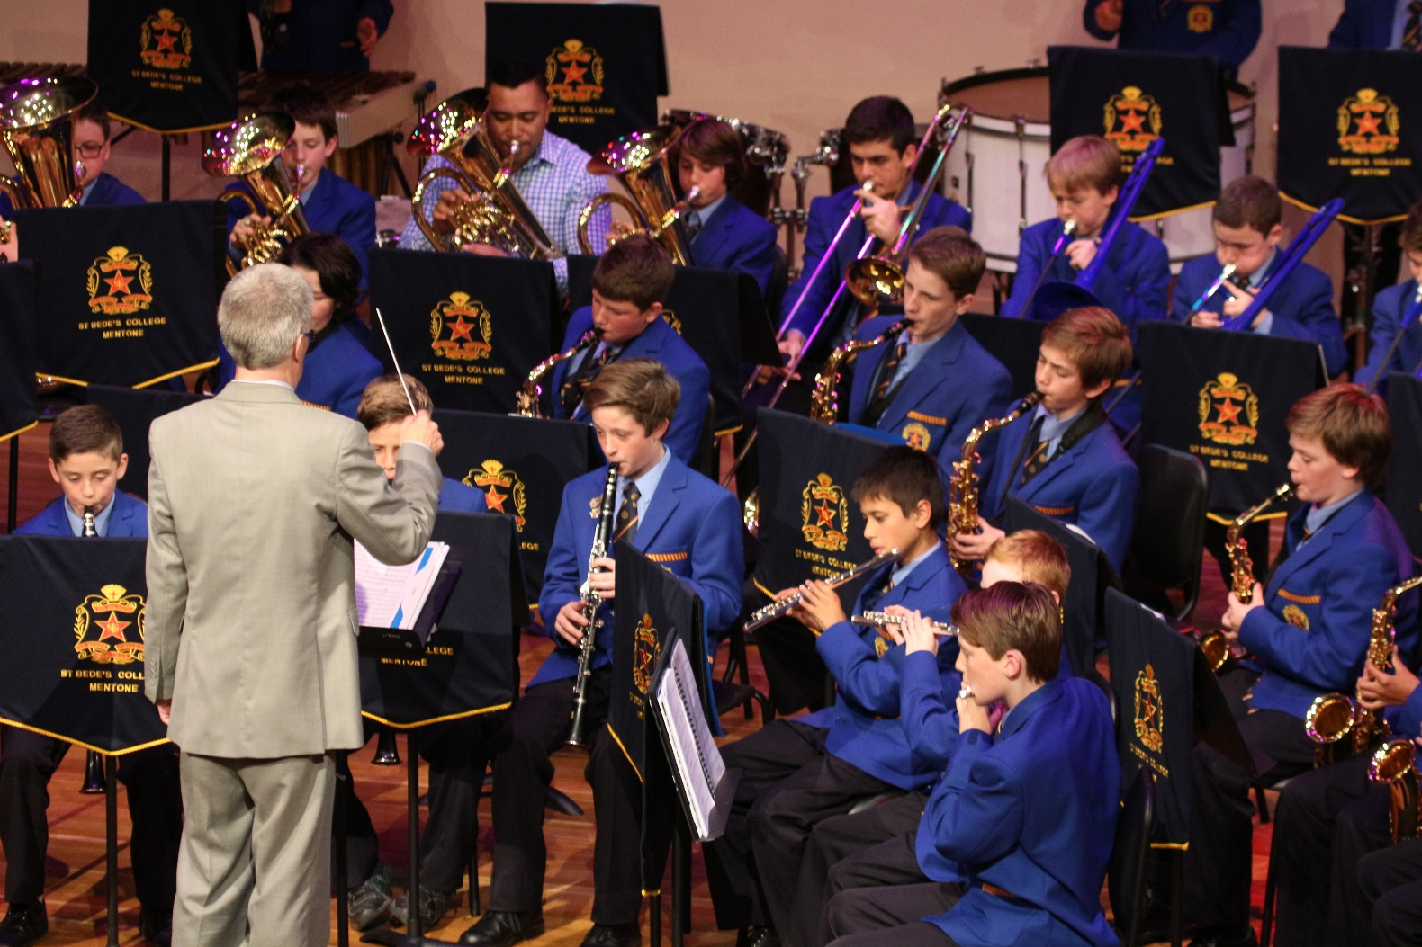

Music Ethos

To promote students musical education and enjoyment of music the College offers a private instrumental tuition program. St Bede’s College has a team of specialist teachers who provide tuition on a range of instruments. Music lessons are scheduled to work with the student’s classroom timetable and will be delivered on a rotational basis to minimise disruption to classroom programs.

If you would like your son to undertake private music lessons at St Bede’s College during 2019, please read the following information and complete the application and hand it in to the Music Department or the Front Office.

St Bede’s College students have the Opportunity to learn the following:

Bass: Electric Bass, Double Bass

Brass: Trumpet, Trombone, Euphonium, Tuba, French Horn

Guitar: Electric Guitar, Classical Guitar

Keyboard: Piano, Keyboard

Percussion: Percussion, Drum Kit

Singing: Contemporary Singing, Classical Singing

Woodwind: Flute, Clarinet, Saxophone

All students learning an instrument are expected to be involved in music ensembles. This involves attendance at rehearsals which are timetabled out of class time, either before school, at lunchtime or after school. Ensemble rehearsal commitments have priority over all other voluntary activities for students who are undertaking instrumental music lessons. We hope that your son can become a participant in this exciting program.

The Enrolment Process

When your enrolment form is handed in, the Director of Music and Music Administrator will allocate a teacher to your son. This process takes approximately one week.

Once allocated, the Instrumental teacher or Music Administrator will contact you and your son via email to advise the date and time of the first lesson. Wherever possible, all lessons are given on a rotating timetable, so that the lessons take place at a different time each week. This means a student will usually miss only two periods of a particular lesson each term.

Years 11 and 12 students are given priority when allocating lesson times outside of the normal timetable (i.e. before school, lunchtime, or after school).

If you have any questions, please contact the Music Administrator on 9582 5999 or via email:
music.admin@stbedes.catholic.edu.au

Lesson Length and Fees

For practical tuition, 29 lessons and one assessment session per year are provided. Fees for these lessons will be payable in a 15 lesson blocks basis. Where a student does not receive a scheduled lesson due to the teacher’s absence for any reason, the teacher will make arrangements for a make-up lesson to be given later in the semester.

The fees are based on the Victorian Music Teachers’ Association recommendation.

Please Note: Where it is not possible to place a student in the nominated lesson type, the College will contact the parent. Shared lessons cannot be provided for piano or drum kit.

Conditions of Enrolment

Where a student misses a lesson, a make-up lesson will be given only in the following cases:

- When the student requests a change to accommodate other school activities such as tests, excursions and sporting commitments, provided you give your music teacher 24 hours prior notice.

- Where the parent is aware their son will be absent from school on the day of the lesson we request you give 24 hours prior notice by emailing: music.admin@stbedes.catholic.edu.au.

- Where the student is ill on the day of his lesson and the parents notify the school via Student Absentees and also advise cancellation of the music lesson.

- Application forms/enrolment fee and payment must be received before your son can commence his music lessons.

- Other than for illness as set out above, make up lessons will not be given unless at least 48 hours prior notice of absence is given. Contact will be made to parents via email informing them of missed lessons without prior notification, lateness and failure to bring the correct resources to a lesson.

Weekly Procedure

The Next Lesson - Lesson times will be emailed to students, so they must check on the date and time of their next lesson and note down the detail on their ICT Device. Students must also check their student email on the day prior to their music lesson just in case the lesson time has been changed. Students who arrive late to lessons should not expect to have this time made up.

Changing Lesson Times - If a music lesson is timetabled to clash with a test in a particular subject, this will become evident from proper use of their ICT Device. Students are to consult their music teacher in advance (i.e. not less than 48 hours prior to the scheduled music lesson). Students must not swap lesson times with other students, without consultation with their music teacher or the Music Administrator.

Leaving Class to Attend a Music Lesson - Students are expected to go promptly to and from music lessons. Students must ensure they see the respective subject teacher for the commencement (or remaining) minutes of that particular period.

Storage of Instruments at School - All instruments should be neatly stored in the Music Department’s allocated storeroom, while they are at the College. Instruments should not be left on top of or next to lockers. Please make sure your son’s instrument is clearly named and has a contact phone number on the case.

Instrumental Music Exams - Students will have the opportunity, and are encouraged, to further their instrumental studies through external music examinations (AMEB, Rock School, ANZCA etc.). The fee for these exams is not included in the Music Tuition account.

One term’s written notice must be given to the Director of Music if tuition is to be terminated. ie: if not continuing tuition for the second block of 15 lessons, fees will not be refunded for students who withdraw prior to the conclusion of a semester. Notice for withdrawal from Program for Semester 2 must be given by Friday 31 May, 2019.

Thank you for enrolling and providing your son with the opportunity to learn and develop his musical skills with our team of Instrumental Teachers.
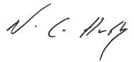

ST BEDE’S COLLEGE
Private Instrumental Music Lessons

To continue or begin Private Instrumental Lessons please complete this form. Payments are made on a semester basis (Block 1 =15 February and Block 2 = 31 May, 2019).

Thank you for enrolling and providing your son with the opportunity to learn and develop his musical skills with our highly talented Instrumental Teachers.

Scheme | Description | Charge  per lesson | Semester Charge  For 15 Lessons
A | 60 minute individual lesson  VCE Music Students / Advanced Students | $66.00 | $990.00
B | 30 minute individual lesson | $33.00 | $495.00
C | 30 minute shared lesson (2 students)  Years 7-9 only  NOTE: Drum Kit and Piano not available for option C. | $21.50 | $322.50
 | Music Record Book (required for all students Years 7-12 |  | $10.00

Block 1 - (Please indicate with “yes”)  Fees will be deducted on  Friday 15 February 2019 |  |  |  |  |  |  | Block 2 - (Please indicate with “yes”)  Fees will be deducted on  Friday 31 May 2019
Name: |  |  |  |  |  |  | Year Level: |  |  |  | Roll / Tutor Group No:
Student Email: |  |  |  |  |  |  |  |  |  | @stbedes.catholic.edu.au
Address:
Suburb: |  |  |  |  |  |  |  |  |  | Post Code:
Parent Contact Name:
Email: |  |  |  |  |  |  |  |  |  | Mobile:
Name of Instrument / Singing Lessons:
Length of Lesson:  (Type “yes” in relevant box) |  | A (1 Hour) |  |  |  |  |  | B (30 mins individual)
C (30 mins shared Years 7-9 only)
NOTE: Drum Kit and Piano not available for Option C

I wish to apply for my son to commence music tuition as listed above. I have read the information provided and agree to give one term’s notice in writing, to the Director of Music, for cancellation of tuition. Notice for withdrawal from Program for the Second block of lessons must be given by Friday 31 May 2019. Automatic deductions will occur for second block of lessons on 31 May if application to withdraw has not been received by the Director of Music or Music Administrator.

Signature of Parent/Guardian: |  | Date:

Private Music Lessons Payment form (Credit Card only)

We/I will pay the prescribed fees and charges as set out by the St Bede’s College Board of Management.

Type of Card: (Indicate with a “yes”) |  | Visa |  | Mastercard

Card Number:

Expiry Date: |  |  | / |  |  |  | Name on Card:

